Handheld PDA/EDAs (Uncategorized)

<https://www.alibaba.com/product-detail/Famous-Mobydata-M92-Qcta-Core-Android_1600205433370.html?spm=a2700.galleryofferlist.topad_classic.d_image.668c6b82WsmnJY>

Price: 1 to 4 pieces US$345.00

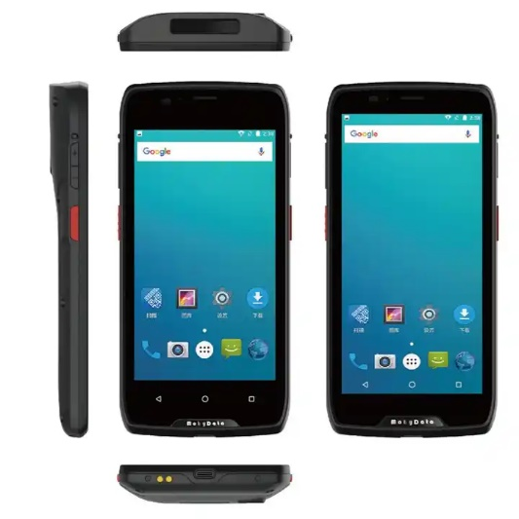>= 5 pieces US$295.00

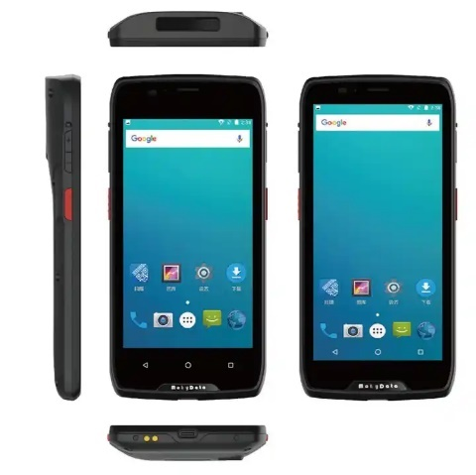

**Product Name:** GAOTek PDA Handheld Computer

**Product ID:** GAOTek-HED-201

**Meta Description:** This PDA Handheld Computer has an dimensions 6.14 in x 2.95 in x 0.55 in (156 mm x 75 mm x 14 mm), display 6.19inch HD (720 x 1500) color screen and a gross weight of 0.44 lb.

**Technical Specifications:**

|  |  |
| --- | --- |
| **CPU** | Octa-Core 2 Ghz |
| **RAM** | 2 GB or 4 GB |
| **ROM** | 16 GB or 64 GB |
| **O.S** | Android 9.0 |
| **Display** | 6.19inch HD (720 x 1500) color screen |
| **Buttons** | Volume up/down, Power button, Custom buttons, Scan button, Home, Menu. Back |
| **Barcode Scanner** | 2D imager |
| **Main Battery** | Rechargeable 3.8V 460000mAh lithium polymer battery pack(Typical Operation time >15hours) |
| **RTC Battery** | Real time clock battery |
| **Camera** | 13 MP auto-focus color rear camera with flash 5 MP/2 MP front-facing camera |
| **RFID** | Supports 13.56 MHz, IS014443A&B and I S015693 standard. Supports NFC |
| **Sensor** | Light sensor Range sensor, Acceleration sensor, Compass, Gyroscope, Barometer |
| **Slot** | Micro SD/TFX1. Micro SIM x 2 |
| **Interfaces** | Type-C USB,3.5 mm Audio port, POGO PIN |
| **Fingerprint module** | Optional |
| **Standard** | Power adaptor, Data cable, One battery |
| **Dimensions** | 6.14 in x 2.95 in x 0.55 in (156mm x 75mm x 14mm) |
| **Weight** | 0.44 lb (0.20 kg) (Battery included) |

<https://alibaba.com/product-detail/JT-980-EDA-PDA-UHF-RFID_62522486597.html?spm=a2700.galleryofferlist.normal_offer.d_image.743a6b82Sb1bFC>

**Price:** 2 to 9 pieces US$750.00

10 to 99 pieces US$730.00

>= 100 pieces US$650.00

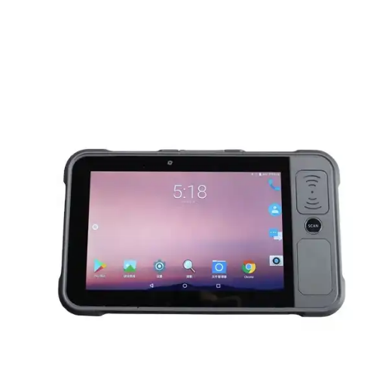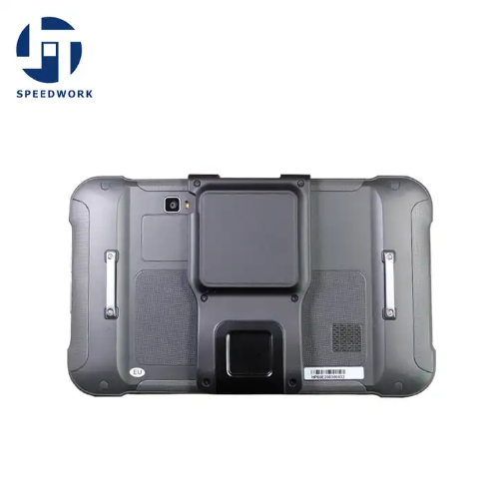

**Product Name:** GAOTek Sled Handheld

**Product ID:** GAOTek-HED-202

**Overview:** GAOTek Sled Handheld with abundant function is an Android 9.0 rugged tablet. With its powerful Qualcomm CPU, 8 inch high screen, 8000 mAh battery and comprehensive data capture option like UHF RFID , barcode scanning , HF RF and fingerprint recognition ,etc., you can find this easy-to-deploy device a valuable helper to increase product logistic , warehousing , identity verification ,meter reading etc.

**Technical Specifications:**

|  |  |
| --- | --- |
| **CPU** | Qualcomm 1.8 GHz Octa-core |
| **RAM+ROM** | 2 GB + 16 GB(Standard) or 3 GB + 32 GB(Upgrade) |
| **Expansion** | Supports up to 128 GB Micro SD card |
| **Operating System** | Android 9.0 |
| **Operating System** | Android 9.0; GMS, Android Enterprise, Zero-Touch, FOTA, Soti MobiControl, Safe UEM supported |
| **SDK** | Jietong Software Development Kit |
| **Language** | Java |
| **Tool** | Eclipse or Android Studio |
| **WLAN** | IEEE802.11 a/b/g/n/ac, 2.4G/5G dual-band, internal antenna |
| **Bluetooth** | Bluetooth 4.2/4.1+HS/4.0/3.0+HS/2.1+EDR |
| **GNSS** | GPS/AGPS, GLONASS, BeiDou, internal antenna |
| **Display** | 8 inch IPS LTPS 1920 x 1200 / IPS LTPS 1280 x 800 |
| **Touch Panel** | Corning Gorilla Glass, multi-touch panel, gloves and wet hands supported |
| **Power** | Li-ion, rechargeable, 8000 mAh |
| Standby: over 500 hours |
| Continuous use: over 10 hours (depending on user environment) |
| Charging time: 5-7 hours (with standard adaptor and USB cable) |
| **Expansion Slot** | 1 slot for SIM card, 1 slot for SIM or TF card |
| **Interfaces** | USB3.0 Type-C, OTG |
| **Audio** | Speaker, microphones |
| **Sensors** | Gravity sensor, light sensor, proximity sensor |
| **Engine** | CM2000-1 module based on Imping Indy R2000 |
| **Frequency** | 865 MHz to 868MHz / 920-925MHz / 902-928MHz |
| **Protocol** | EPC C1 GEN2 / ISO18000-6C |
| **Antenna** | Circular polarization (default UHF, 3 dBi ; UHF with pistol grip, 4 dBi) |
| **Power** | 1W (30dBm, +5dBm to +30dBm adjustable) |
| **R/W range** | Less than 25 m (indoors); less than 15 m (open outdoors, Imping MR6 tag); |
| **Reading rate** | Less than 200 tags/s (circular polarization) |
| **Frequency** | 13.56 MHz |
| **Protocol** | ISO14443A/B, ISO15693, NFC-IP1, NFC-IP2, etc. |
| **Chips** | M1 card (S50, S70), CPU card, NFC tags, etc. |
| **Range** | 2-4 cm |
| **Dimensions** | (250.8 mm x 152.0 mm x 15.0 mm )9.87 in x 5.98 in x 0.59 in. (for standard version) |
| **Weight** | 1.54 lb(0.7 kg ) (for standard version) |

<https://www.alibaba.com/product-detail/Handheld-Rugged-Android-Terminal-5-Inch_1600693280162.html?spm=a2700.galleryofferlist.p_offer.d_image.38ec8e79eB5etc&s=p>

**Price:** 2 to 99 pieces US$325.00

100 to 999 pieces US$315.00

>= 1000 pieces US$300.00

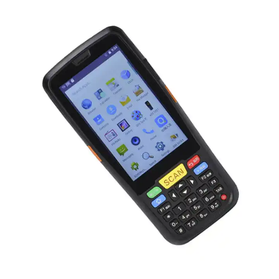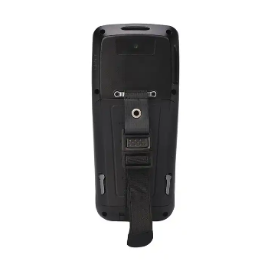

**Product Name:** GAOTek Pda Barcode Scanners

**Product ID:** GAOTek-HED-203

**Meta Description:** This PDA Handheld Computer has an battery capacity of 4000 mAh , gross weight of 0.44 lb (0.2 kg ) and a memory capacity of 2 GB+16 GB (optional 3GB+32GB).

**Technical Specifications:**

|  |  |
| --- | --- |
| **Operating System** | Android 7.0 |
| **Processor Type** | Quad core 1.2 GHZ |
| **Style** | Handheld Computer |
| **Memory Capacity** | 2 GB+16 GB (optional 3 GB+32 GB) |
| **Screen Size** | 5 inch |
| **Software development kit (SDK)** | Yes |
| **Display** | 7.0 IPS TFT LCD,720 P |
| **Communication** | 4 G/ WCDMA/EDGE/GSM/USB,UART |
| **WIFI** | IEEE 802.11a/b/g/n |
| **wireless** | V4.2(support BLE)V3.0/V2.1 |
| **External input** | audio input |
| **Battery capacity** | 4000 mAh |
| **SD/TF** | Support max 128 GB Touch Panel: Capacitive Touch Panel |
| **Touch Panel** | Capacitive Touch Panel |
| **Barcode scanner** | 1D or 2D Barcode Scanner Optional |
| **RFID** | LF(125 KHz) or LF(134.2 KHz)/HF(13.56 MHZ)/UHF(900 MHZ) Optional |
| **Weight** | 0.44 lb (0.2 kg ) |

<https://www.alibaba.com/product-detail/Urovo-DT50Q-Handheld-Mobile-Computer-Rugged_1700003899059.html?spm=a2700.galleryofferlist.p_offer.d_price.38ec8e79eB5etc&s=p>

**Price:** 1 to 10 pieces US$430.00

11 to 50 pieces US$390.00

>= 51 pieces US$350.00

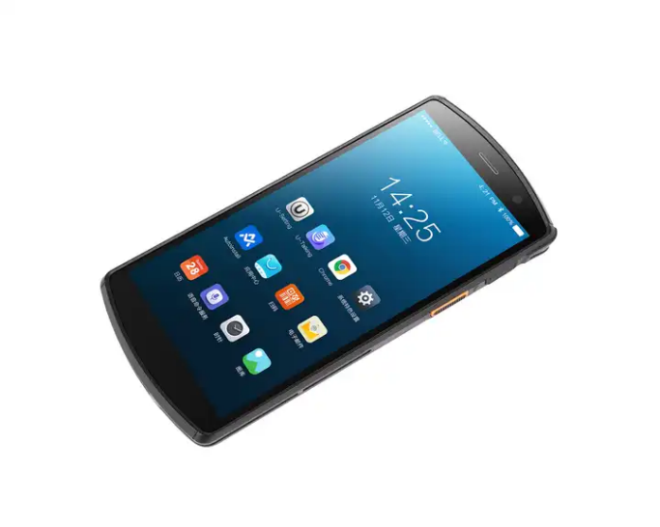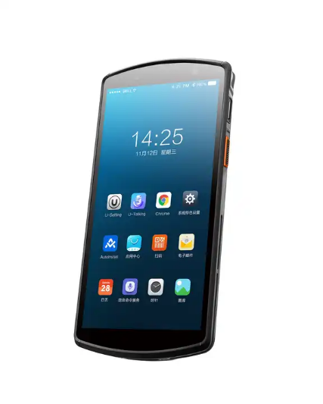

**Product Name:** GAOTek Handheld Mobile Computer

**Product ID:** GAOTek-HED-204

**Overview:** GAOTek Handheld Mobile Computer is an Android 9.0 mobile device, that has been IP67 rated and 1.5m drop tested. Featuring a 1D/2D barcode imager, NFC, RFID,  
triple camera and biometric fingerprint module to gather all the information that your enterprise needs, in any form, from any point.

**Technical Specifications:**

|  |  |
| --- | --- |
| **Operating System** | Android 9.0 |
| **Processor Type** | Octa-core 1.8 GHz |
| **Style** | Handheld Computer |
| **Memory Capacity** | 4 G + 64 G |
| **Screen Size** | 5.7 inch (1440 x 720) |
| **Location** | Concurrent GPS, GLONASS, Galileo, BeiDou, A-GPS |
| **Wireless communication** | Wi-Fi, NFC |
| **Bluetooth** | BT5.0 + BR or EDR + BLE |
| **Barcode scanner** | 1D or 2D imager |
| **camera** | 16 MP + 2 MP rear, 2 MP or 5 MP front |
| **battery** | 3.8 V 4300 mAh battery (more than 10 h) |
| **interface** | 256 GB Micro-SD, 2 Nano SIM Slot |
| **environment** | IP65 rated, multiple 1.5m drops |
| **Weight** | 0.55 lb (0.25 kg ) (include battery) |

<https://www.alibaba.com/product-detail/Urovo-RT40-Handheld-Data-Collector-Android_1600189043031.html?spm=a2700.galleryofferlist.p_offer.d_title.38ec8e79eB5etc&s=p>

**Price:** 1 piece US$600.00 to US$870.00

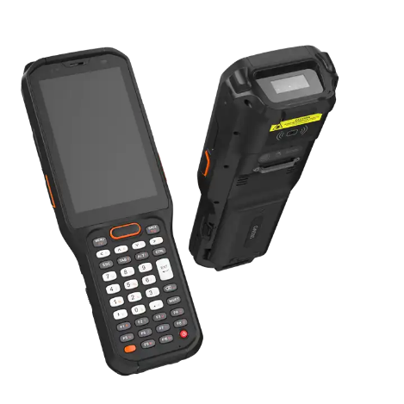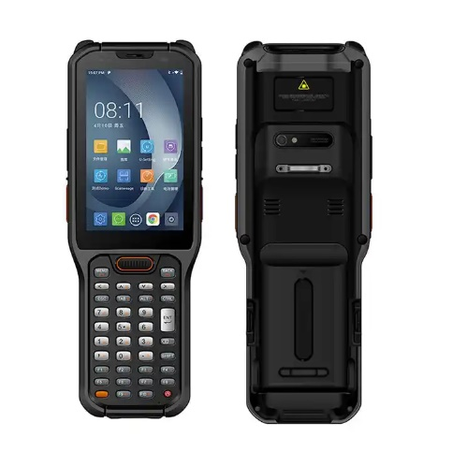

**Product Name:** GAOTek Handheld Data Collector

**Product ID:** GAOTek-HED-205

**Overview:** GAOTek Handheld Data Collectorequipped with heater of LCD/scan engine. Your cold chain solution. Hot-swap battery design, exchanges exhausted battery without reboot. Increase your effciency.Qualcomm Octa-core 2.2GHz high-efficiency processor and cutting-edge Android Q operating system, gives you unparalleled performance. 38 keys island-style keyboard + 4" giant touch screen, intuitive operation reaction, accurate even with glove hands.  
* Built-in industrial-leading scanner engine, captures 1D/2D barcodes on screen and paper even if they are contaminated, wrinkled or distorted, 15m long-range scanner engine is optional.

**Technical Specifications:**

|  |  |
| --- | --- |
| **Operating System** | Android Q (10) |
| **Processor Type** | Qualcomm Octa-core 2.2 GHz |
| **Style** | Handheld Computer |
| **Memory Capacity** | 4GB RAM / 64GB ROM |
| **Screen Size** | 4inch 480 x 800 pixel |
| **Main battery** | 3.85 V or 5,200 mAh |
| **battery** | Support battery swap |
| **Sealing** | IP68 |
| **Dimension(thinnest)** | 7.8 in x 2.2 in x 1.2 in (199 mm x 58 mm x 29 mm) |
| **Dimension(in)** | 78.34 in x 22.83 in x 11.41 in |
| **Weight** | 0.99 lb (0.45 kg) |

[https://www.alibaba.com/product-detail/Handheld-Android-9-0-1P66-Rugged_1600620191470.html?spm=a2700.galleryofferlist.p_offer.d_title.38ec8e79eB5etc&s=p](https://www.alibaba.com/product-detail/Handheld-Android-9-0-1P66-Rugged_1600620191470.html?spm=a2700.galleryofferlist.p_offer.d_title.38ec8e79eB5etc&s=p%20)

**Price:** 1 to 99 pieces US$299.00

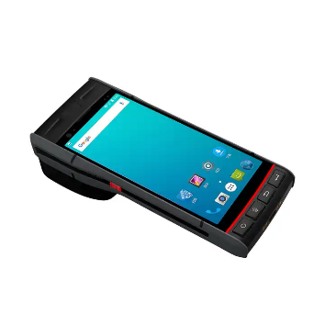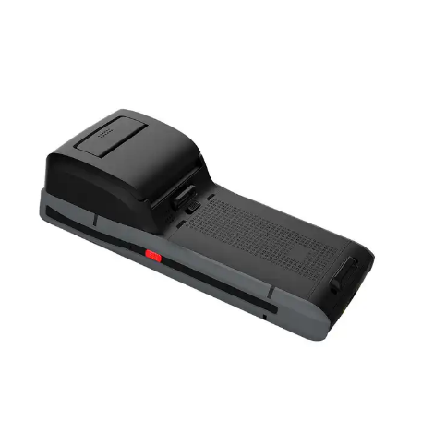>= 100 pieces US$229.00

**Product Name:** GAOTek Handheld Thermal Printer

**Product ID:** GAOTek-HED-206

**Overview:** GAOTek Handheld Thermal Printer has S60 self -adhesive printing terminal and built-in high-speed sticker printing print order anytime, anywhere. It has a large capacity paper bin . Its has a stable and durable body and breaks all troubles. And has a high performance barcode scanning. Most good quality of data transmission and a wireless connection. Its support Type-C fast charging optional charging .

**Technical Specifications:**

|  |  |
| --- | --- |
| **CPU** | Cortex-A53 Quad-core 64-bit 2.0GHz |
| high-performance processor |
| **RAM+ROM** | 2 GB+16 GB |
| Supports up to 3 GB+32 GB |
| **Expand memory** | Micro SD(TF) Supports up to 128 GB |
| **System** | Android 9.0 |
| **WLAN** | Dual-band 2.4GHz or 5GHz, |
| Supporting IEEE 802 a/b/g/n/ac protocol |
| **WWAN** | 2G:GSM(850/900/1800/1900mhz) |
| 3G:WCDMA(850/900/1900/2100mhz) |
| 4G: FDD:B1/B3/B4/B7/B8/B12/B20 |
| TDD:B38/B39/B40/B41 |
|  |  |
| **Display** | 5.5 inch IPS color display with resolution 720 x 1440 |
| **TP** | Corning Gorilla glass, Supports multi-touch |
| Supported gloves and wet hands |
| **Battery capacity** | Rechargeable polymer battery (3.8V 5200MAh) removable |
| **Expansion** | PSAM x 2, Nano SIM card x 1 , TF card × 1 |
| **Card slot** |
| **Communication interface** | Type-C USB x 1, OTG |
| **Audio** | Speaker (mono), Microphone, Earpiece |
| **Keypad** | Power button, Volume +/- button, Scan button × 2 |
| Handle scan button ×1 |
| **Sensors** | Gravity sensor, Light sensor, Proximity sensor, |
| Vibration motor |
| **2D Imager scanner** | Honeywell N3603 |
| **Print points** | 384 dots |
| **Paper width** | 2.2 in (58 mm) |
| **Paper diameter** | 1.3 in (35 mm) |
| **Rear camera** | 13 MP HD camera, auto focus, |
| Flash, Anti-shake, Macro shooting |
| **Front camera** | 2 MP color camera |
| **Frequency** | 13.56 MHz |
| **Protocol** | Support ISO14443A/B, 15693 agreement |
| **Distance** | 0.7 in to 1.96 in |
| **Drop specification** | 6 sides Supports 1.2 meters drops and 30 times |
| to the concrete within the operating temperature |
| **Rolling test** | 500×0.5m rolling for 6 sides |
| **Sealing** | IP66 |
| **Environment humidity** | 5%RH--95%RH(non-condensing) |
| **Operating temperature** | -4 **°**F to 131 **°**F (-20 **°**C to 55 **°**C) |
| **Storage temperature** | -40 **°**F to 158 **°**F (-40 **°**C to 70 **°**C) |
| **Dimensions** | 6.2 in x 2.9 in x 4.8 in (159mm×75mm×124mm) |
| **Weight** | Greater than 1.1 lb (0.50kg) |

<https://www.alibaba.com/product-detail/Long-range-Read-UHF-RFID-C72_1600617739500.html?spm=a2700.galleryofferlist.p_offer.d_title.38ec8e79eB5etc&s=p>

**Price:** 1 to 49 pieces US$550.00

50 to 99 pieces US$530.00

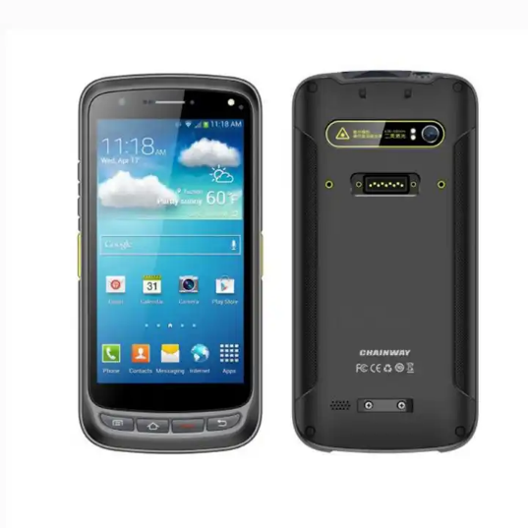>= 100 pieces US$490.00

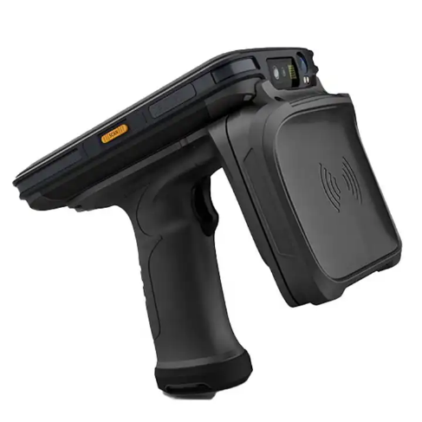

**Product Name:** GAOTek handheld reader PDA

**Product ID:** GAOTek-HED-207

**Overview:** GAOTek handheld reader PDA is a high-performance ultra-high frequency intelligent handheld terminal for information r &amp; d and upgrading. C 72 combines powerful UHF ultra-high frequency read and write functions and has better sensitivity, which is helpful to realize more accurate and faster data acquisition. With Android operating system and high-performance processor, C72 is widely used in asset management, clothing inventory, ve- hicle management, high-speed charging, warehouse management, financial management and other fields.

**Technical Specifications:**

|  |  |
| --- | --- |
| **CPU** | Cortex-A53 Octa-core 2.5GHz |
| **RAM+ROM** | 2GB+16GB |
| **Expansion** | Supports up to 128 GB Micro SD card |
| **Operating System** | Android 8.1 or Android 11 |
| **Display** | 5.2 inch IPS FHD 1920x1080 |
| **Touch Panel** | Corning Gorilla Glass, multi-touch panel, gloves and wet hands supported |
| **Power** | Li-ion, rechargeable, 8000mAh;Standby: over 500 hours; Continuous use: over 12 hours (depending on user environment);Continuous use: over 12 hours (depending on user environment) |
| **Expansion Slot** | 1 slot for SIM card, 1 slot for SIM or TF card |
| **Interfaces** | USB 2.0 Type-C, OTG, Octa-core version supports Type C headphones |
| **Audio** | Speaker, 2 microphones |
| **Keypad** | 4 front keys, 1 power key, 2 scan keys, 1 multifunctional key |
| **Sensors** | Gravity sensor, light sensor, proximity sensor |
| **Camera** | 13 MP Autofocus with flash |
| **Frequency** | 865 MHz to 868 MHz or 920 to 925MHz or 902-928MHz |
| **Protocol** | EPC C1 GEN2 or ISO18000 to 6C |
| **Antenna** | Linear polarization(1.8dBi); circular polarization (4dBi) |
| **R/W range** | polarization, open outdoors); less than 21m (linear polarization, indoors); less than7m (linear polarization, open outdoors) |
| **1D Symbologies** | UPC/EAN, Code128, Code39, Code93, Code11, Interleaved 2 of 5, Discrete 2 of 5, Chinese 2 of 5, Coda bar, MSI, RSS, etc. |
| **2D Imager Scanner (Octa-core)** | Zebra: SE4750/ SE4750MR |
| **Rate** | Greater than 150ms |
| **Range** | 20 cm to 40 cm |
| **FAR** | 1/10000000 |
| **Protocol** | ISO/IEC 19794-6,GB/T 20979-2007 |
|  | |
| **Frequency** | 13.56MHz |
| **Standard** | AC Adaptor, USB Cable, etc. |
| **Optional** | Cradle, Holster , etc. |
| **Drop Specification** | Multiple 1.5m/4.9ft drops (at least 20 times) to the concrete across the operating temperature range |
| **Tumble Specification** | 1000 x 0.5m/1.6ft falls at room temperature |
| **Sealing** | Host IP65 per IEC sealing specifications |
| **ESD** | ±15KV air discharge, ±6KV conductive discharge |
| **Humidity** | 5%RH to 95%RH non condensing |
| **Storage Temp.** | -40 **°**F to 158 **°**F (-40 **°**C to 70 **°**C) |
| **Operating Temp.** | -4 **°**F to 131 **°**F (-20 **°**C to 55 **°**C) |
| **Dimensions** | (6.46 in x 3.15 in x 0.96 in) (164.2 mm x 80.0 mm x 24.3 mm) |
| **Weight** | 1.4 lb (0.65 kg) |